Azure - "Web App" is the most useful service for us. It also covers hosting of "Web API" apps.  
All users - 10 free Web Apps.  
In setup, select "free" if available, otherwise "shared" or start a Virtual Machine.

Students - 10 free Web Apps.  
If you go over that then "shared" is low cost against your 1 year credit and easy to work with from Visual Studio.

Azure Portal  
"+" to create a new resource.

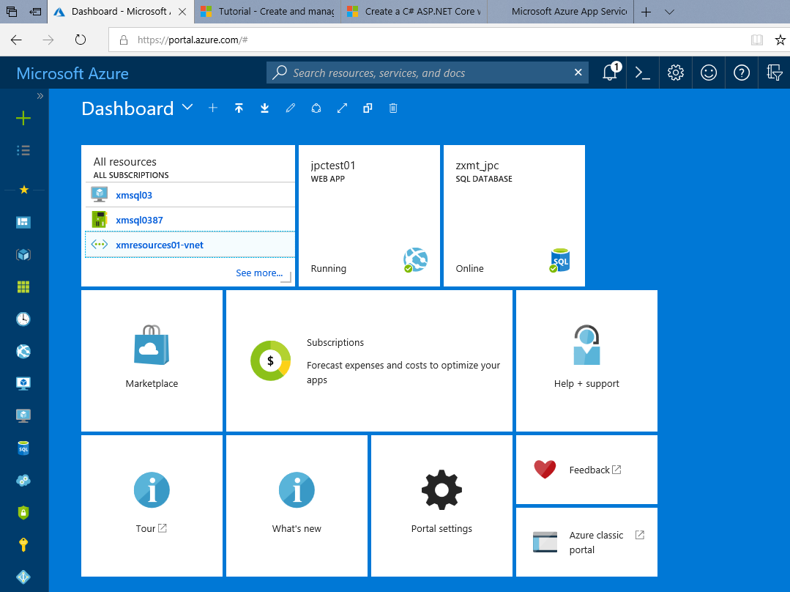

Select "Web App"

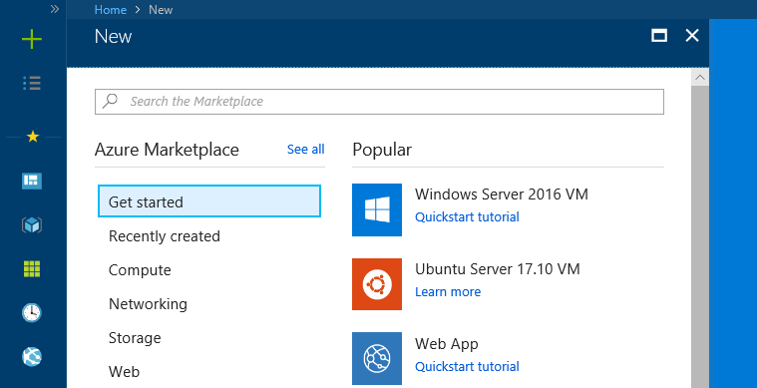

Filling out the form.  
In this case I already had a "Resource Group" so I could "use existing for that".  
For "App Service Plan", my existing plan was based in "USA West" and I wanted to change to "Australia East".  
I therefore needed to create a new "App Service plan" - jpcappservice02 - to host this and future apps in Australia.

Note the Pricing Tier "F1 Free".  
That is a little difficult to find. On its sub-form, second screen shot below, we need to click first on "Dev/Test".

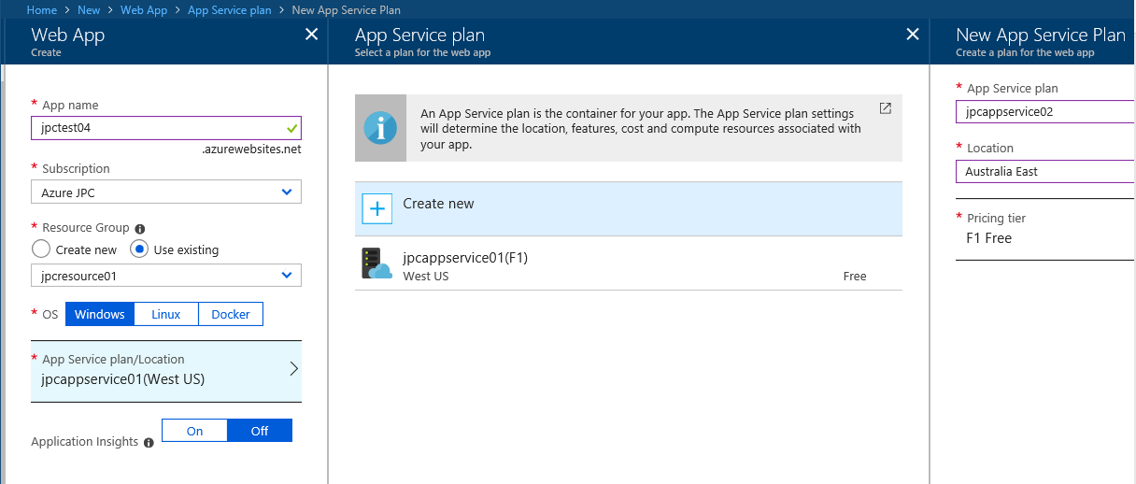

HOWTO get free websites, click first on "Dev/Test".  
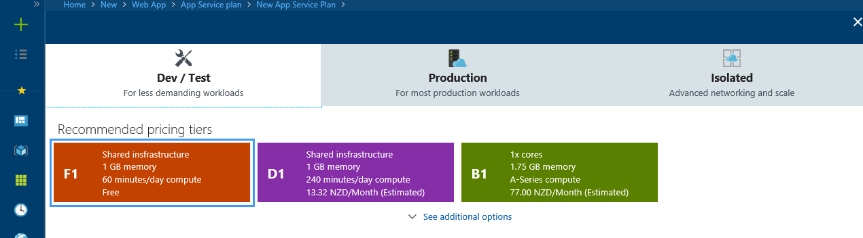

Check the summary panel (not shown, similar to above) then click its "Create" button.  
We can click on "Notifications" to see progress. After 1 to 2 minutes we see a success notification:  
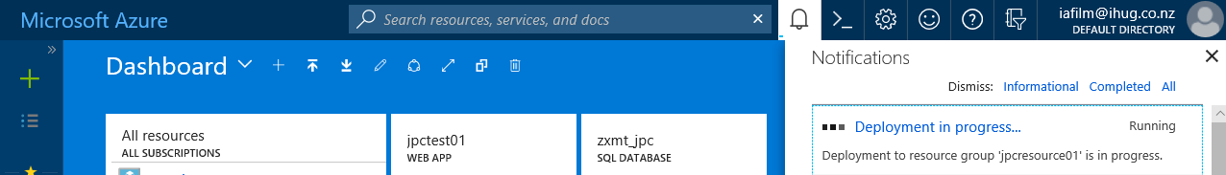 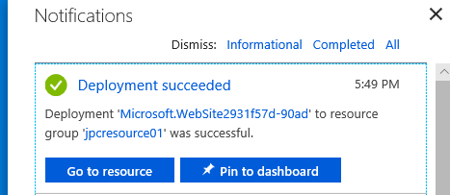

The simplest way to publish our app, is via the "publish to Azure" method in Visual Studio.  
The Internet URL is based on the app name with ".azurewebsites.net" appended - for this example:  
<https://jpctest04.azurewebsites.net>